TEST CASES

Test Case # 1

Description of Test Case: Player Collides with Enemy

Data Set: Arrow Keys

Pre-Condition: Player alive

Expected Result:

* Mouse Clicked of Play Button: Game Starts
* Mouse Clicked of Help Button: Help Screen
* Mouse Clicked of Quit Button: Applet Exits

Actual Result:

* Mouse Clicked of Play Button: Game Started
* Mouse Clicked of Help Button: Help Screen
* Mouse Clicked of Quit Button: Applet Exited

Screenshots:

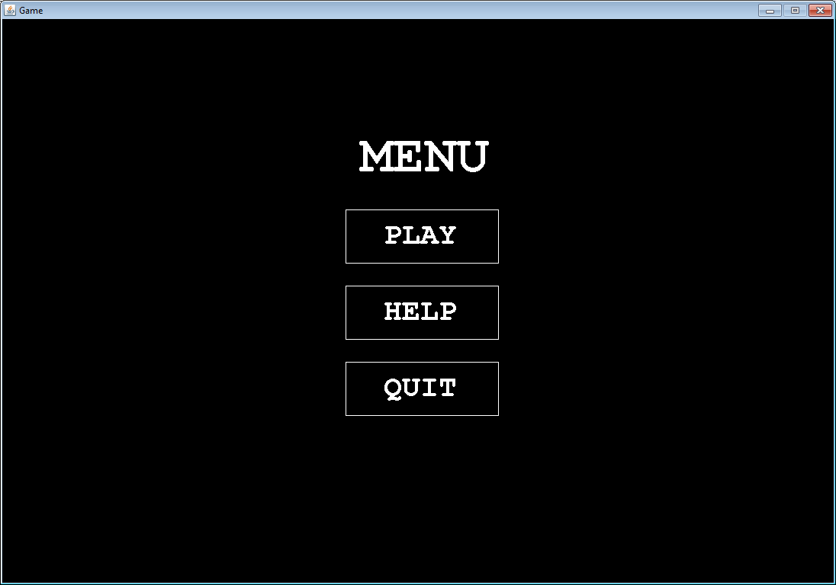 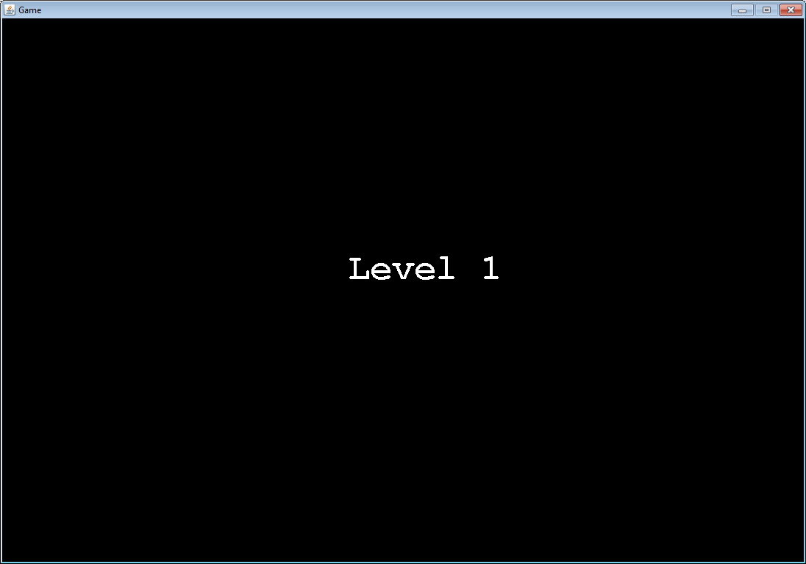

Menu Screen Game Start

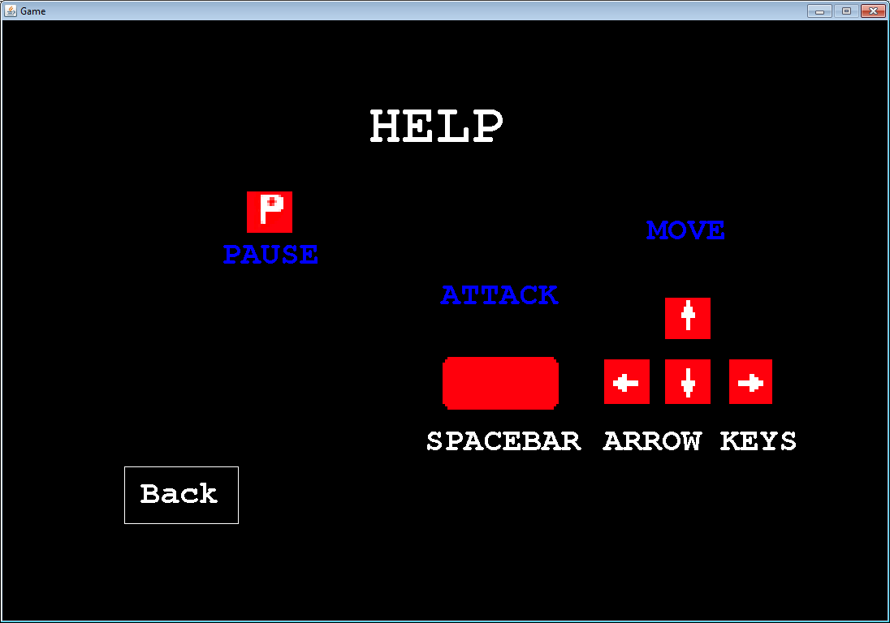

Help Screen

Test Case # 2

Description of Test Case: Player Collides with Enemy

Data Set: Integer for health

Pre-Condition: Player alive

Expected Result:

* Small player should lose health when collides with enemies
* Big player should become small when collides with enemies

Actual Result:

* Small player lost health when collided with enemies
* Big player became small when collided with enemies

Screenshots:

SMALL PLAYER

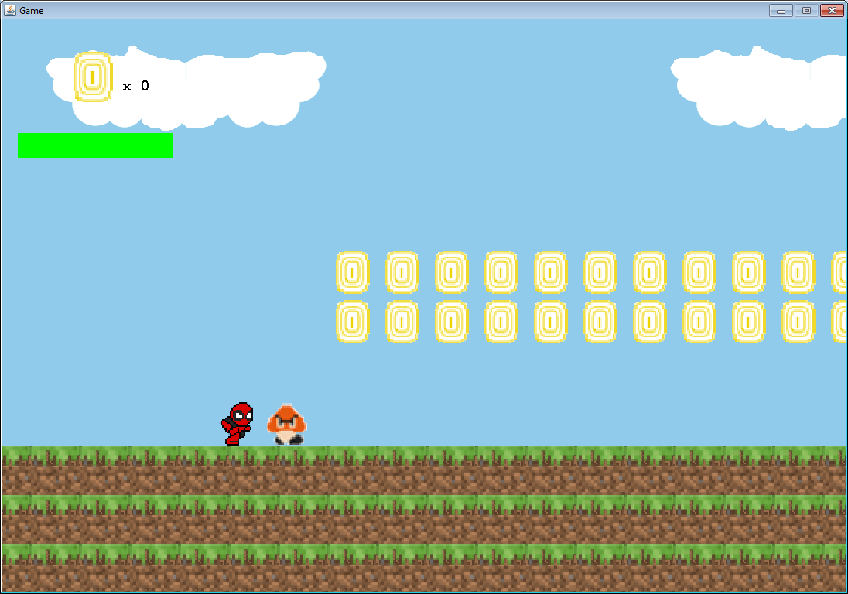 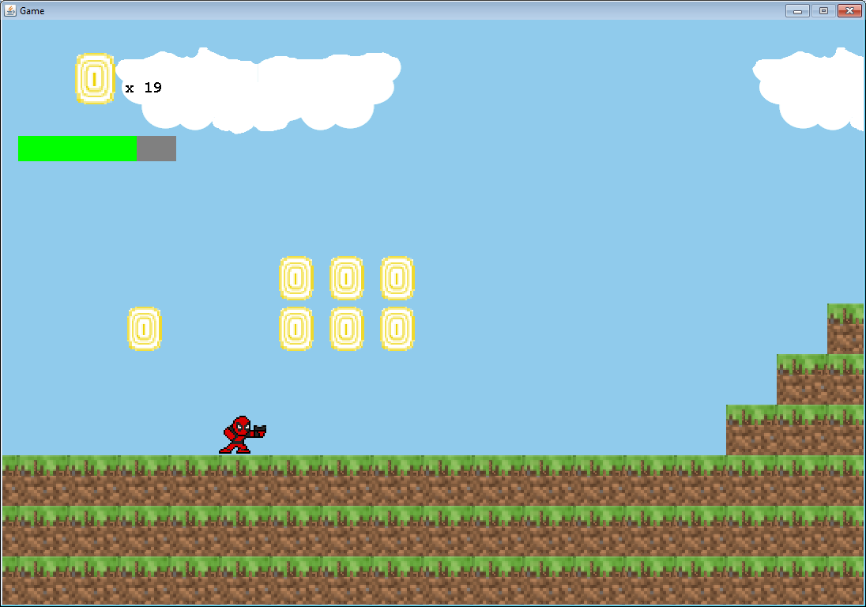

Player Collided Player Lost Health

BIG PLAYER:

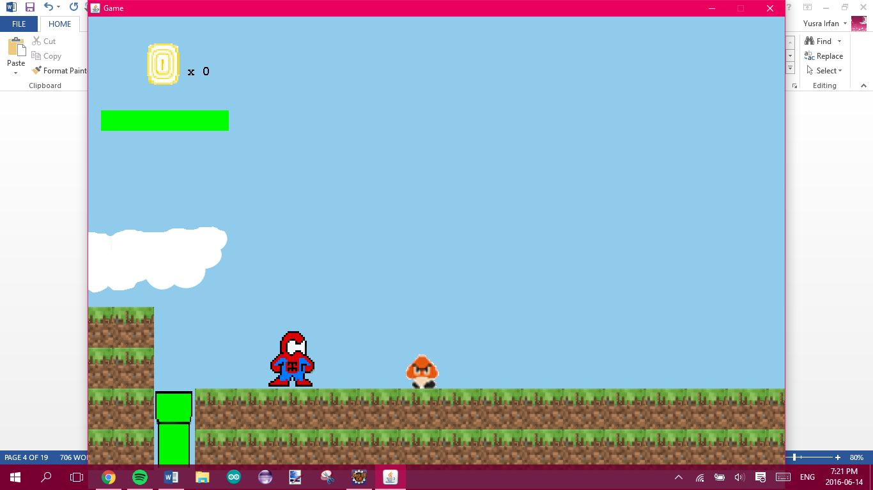 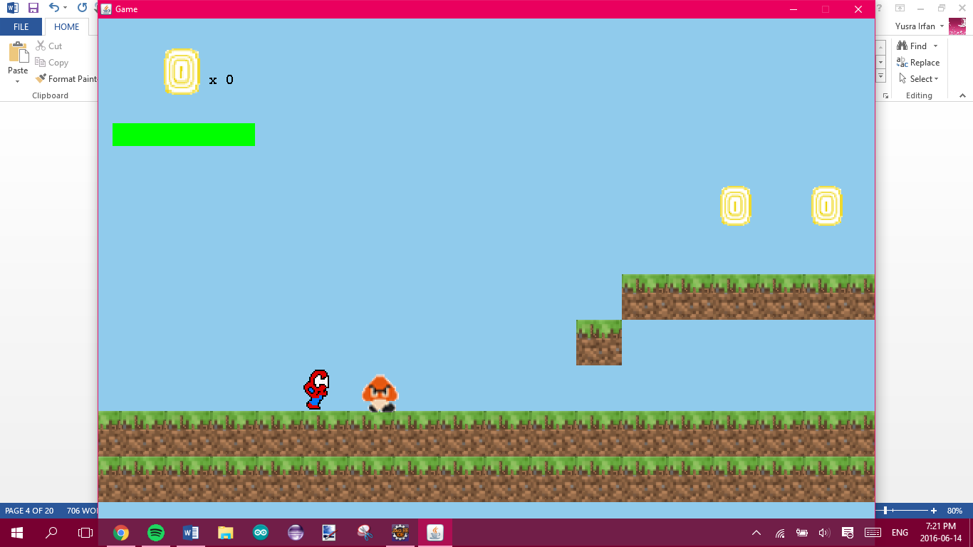

Player Collides with enemy Player becomes small

Test Case # 3

Description of Test Case: Player Jumping

Data Set: Arrow Keys: up

Pre-Condition: Player alive

Expected Result: Player should jump and collide with tiles

Actual Result: Player jumped and collided with the tile above

Screenshots:

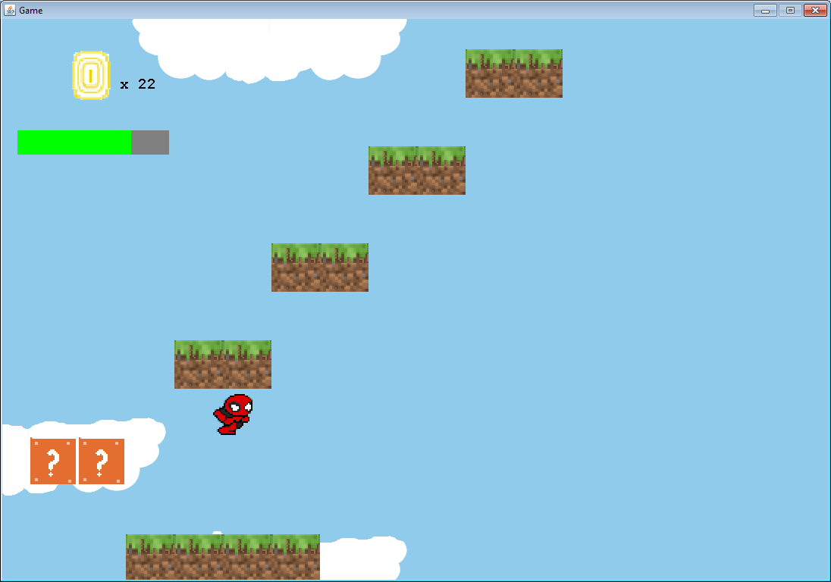

Test Case # 4

Description of Test Case: Player shoots Enemy

Data Set: Spacebar

Pre-Condition: Player alive

Expected Result: Player Attack should collide with enemies and enemies should die

Actual Result: Player Attacked and the enemy died

Screenshots:

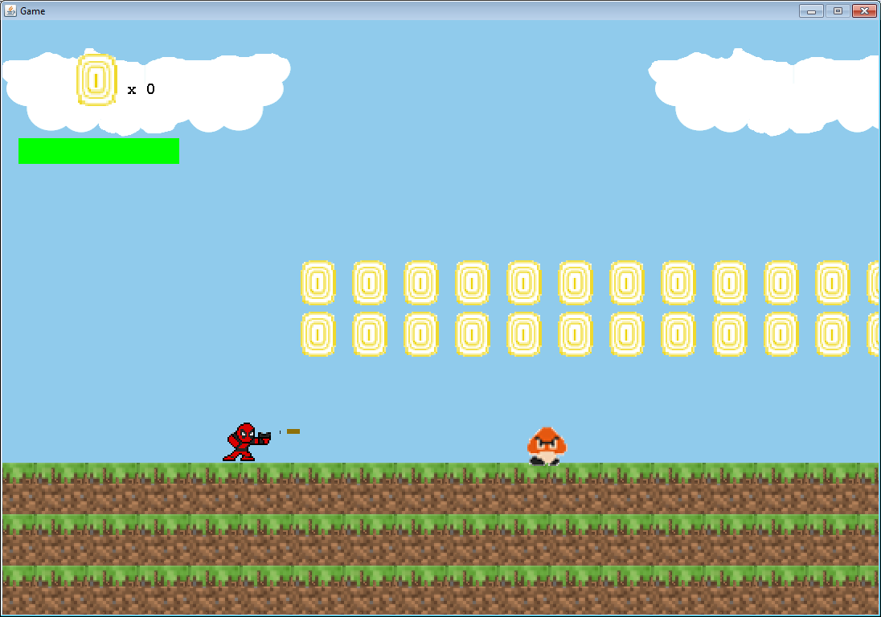

Player Attacks

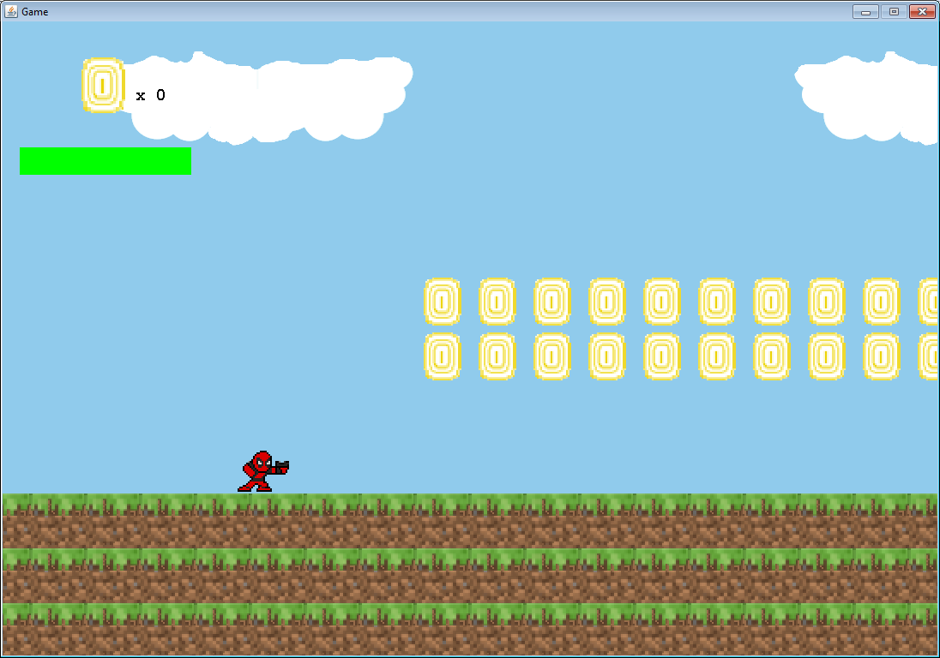

Enemy died

Test Case # 5

Description of Test Case: Player collects coins

Data Set: Spacebar

Pre-Condition: Player alive

Expected Result: Player Attack should collide with enemies and enemies should die

Actual Result: Player Attacked and the enemy died

Screenshots:

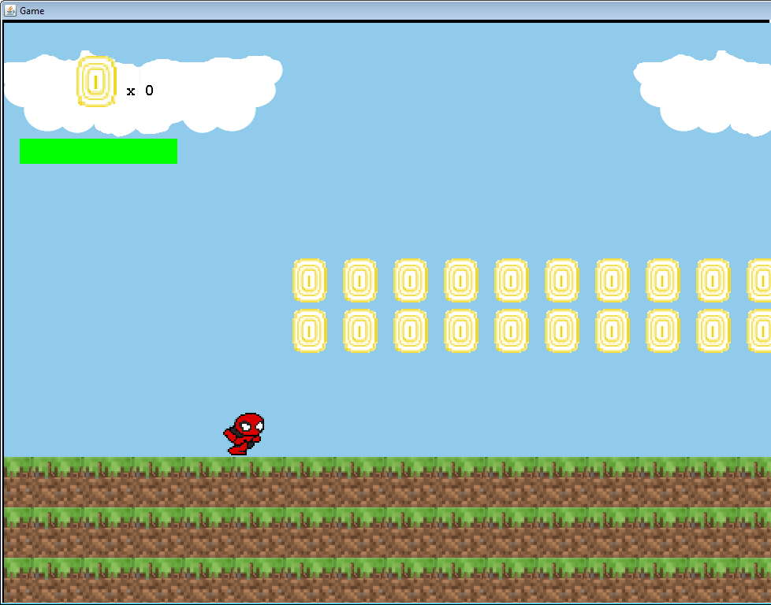

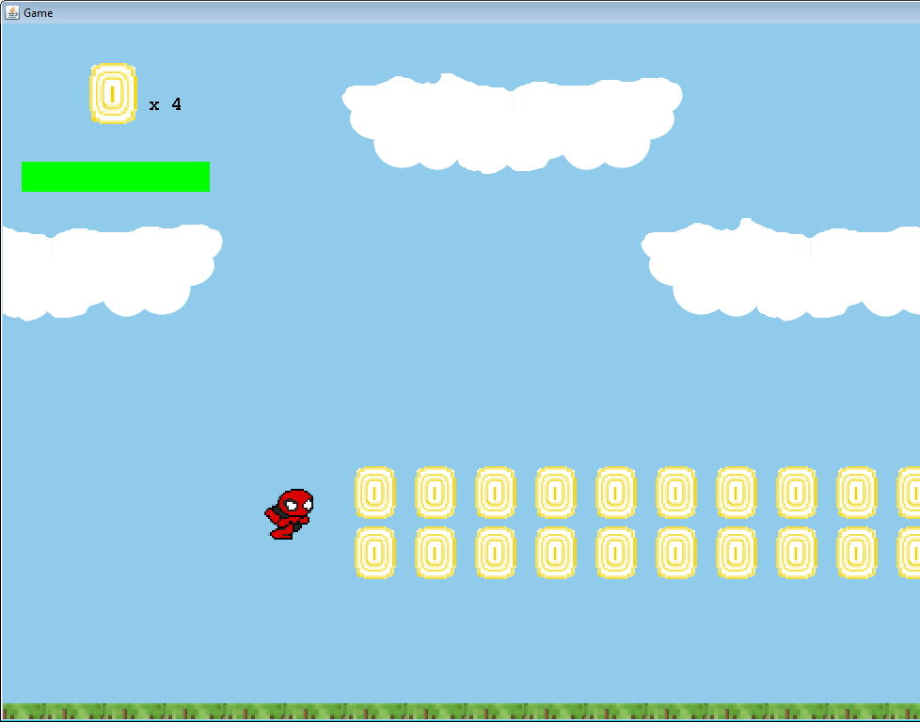

Test Case # 6

Description of Test Case: Player lands on top of enemy

Data Set: Arrow Keys

Pre-Condition: Player alive

Expected Result: Player’s feet should collide with enemies and enemies should die

Actual Result: Player landed on enemy and the enemy died

Screenshots:

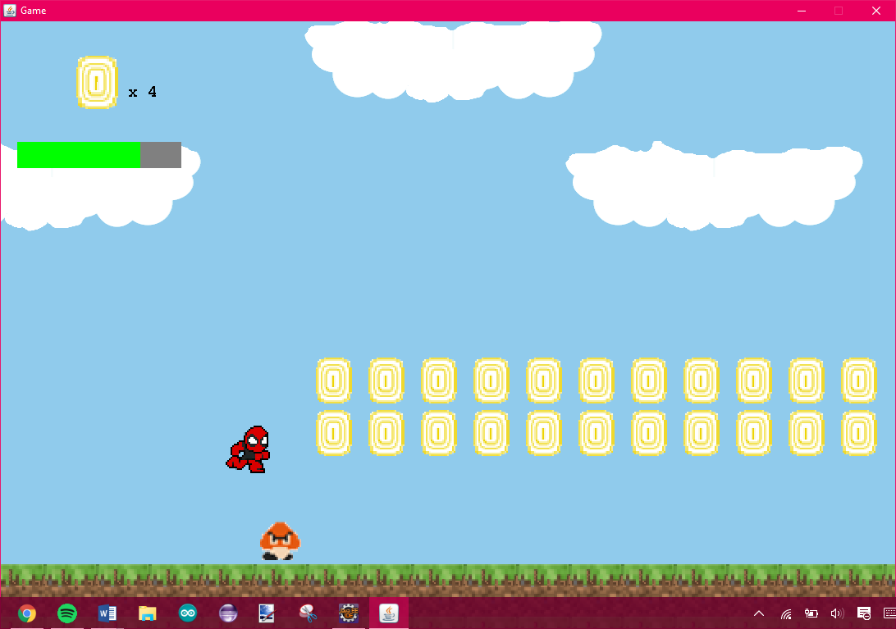

Player Jumps on top of the enemy

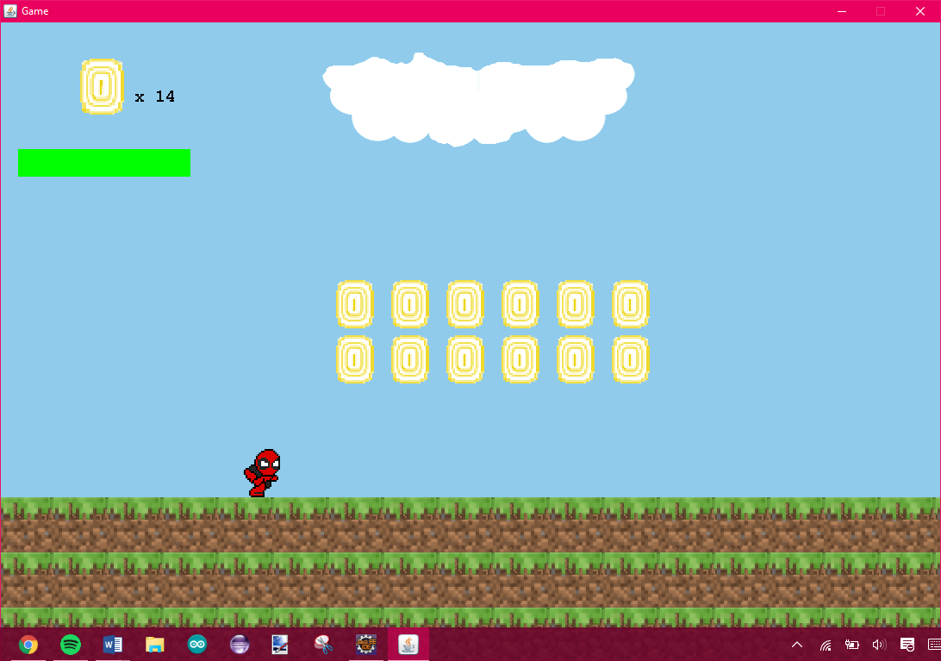

Enemy dies

Test Case # 7

Description of Test Case: Player goes to the next level

Data Set: Arrow Keys (Right)

Pre-Condition: Player alive

Expected Result: Player should collide with the portal and go to the next level

Actual Result: Player collided with the portal and went to the next level

Screenshots:



Level 1

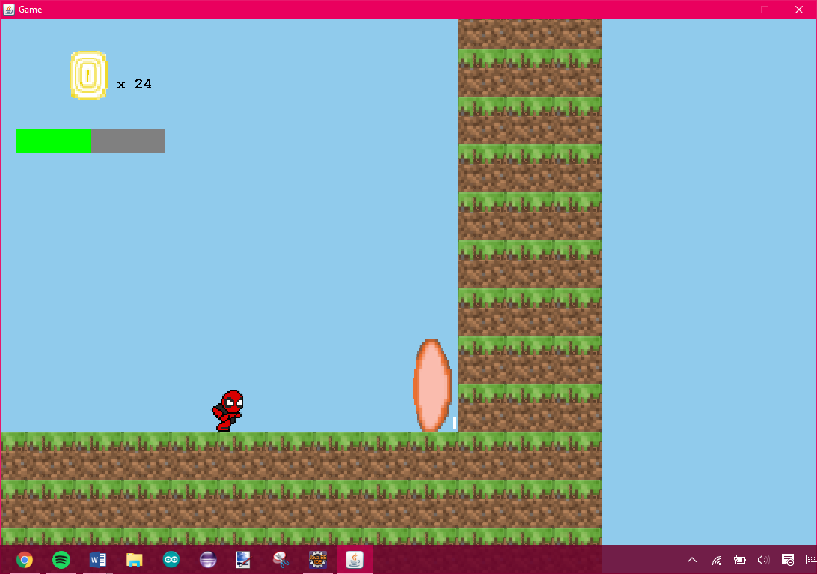

Player goes towards the portal and collides

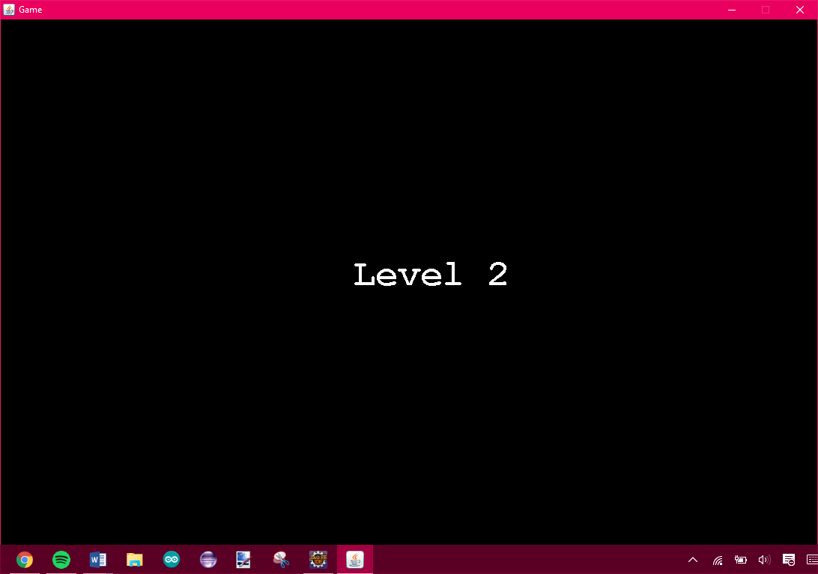

Level 2

Test Case # 8

Description of Test Case: Changes Player and Increase in health

Data Set: Arrow Keys

Pre-Condition: Player alive and Level 2

Expected Result: Player should collide with another character picture and change characters with full health

Actual Result: Player collided with another character picture and changed characters with full health

Screenshots:

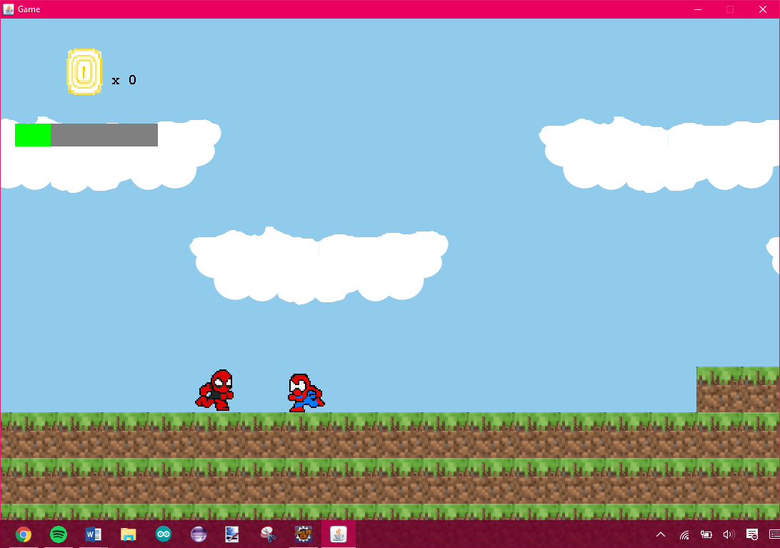

Player collides with another character with less health

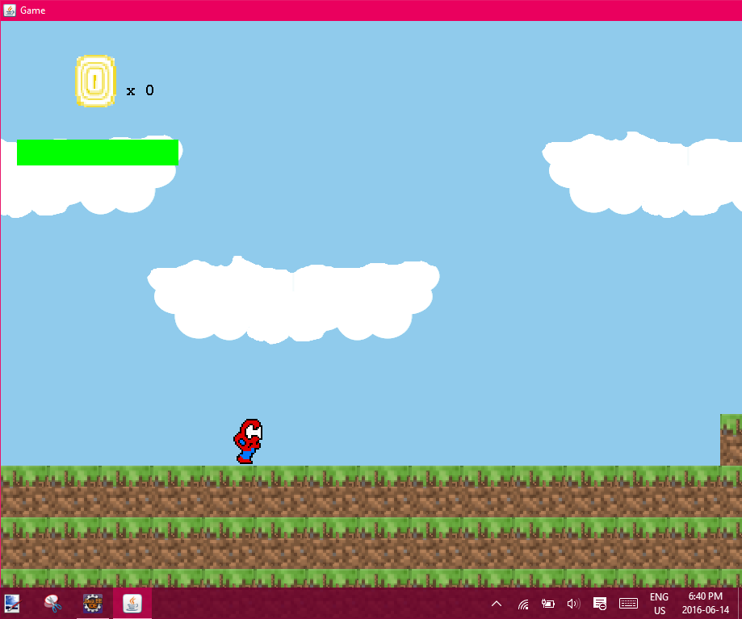

Player character changes and health increases

Test Case # 9

Description of Test Case: Pause

Data Set: ‘P’ Key

Pre-Condition: Player alive

Expected Result: Player and enemies should stop and pause screen should come up

Actual Result: Player and enemies stopped and pause screen came up

Screenshots:

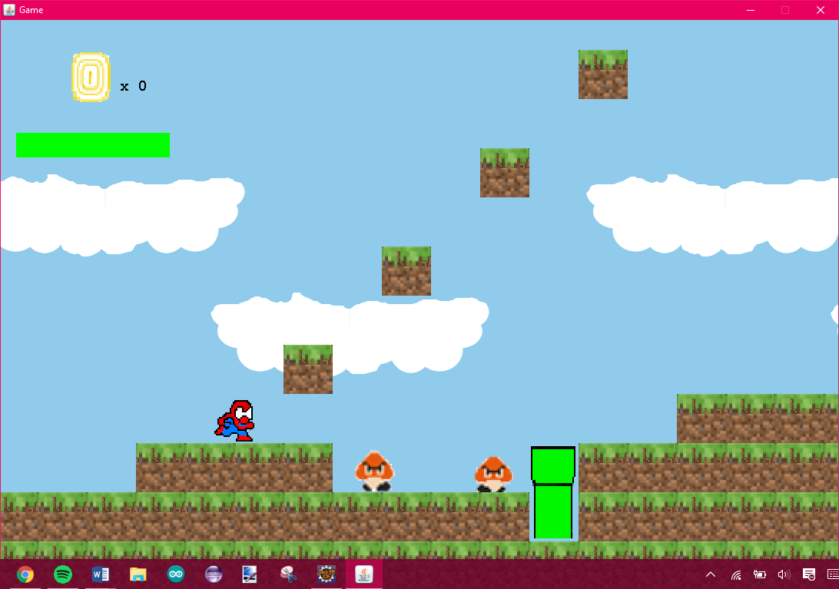

Before Pause

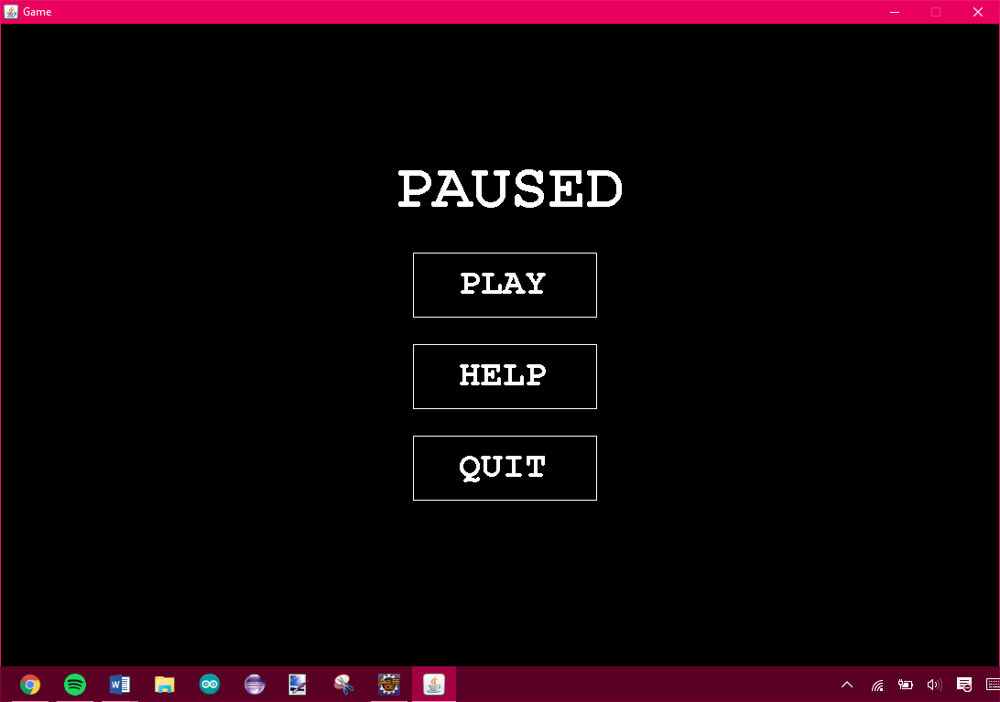

Pause Screen



After play was clicked on pause screen

Test Case # 10

Description of Test Case: Power up (Coin)

Data Set: Arrow Keys (UP)

Pre-Condition: Player alive

Expected Result: Player should collide with a power up tile and a coin should appear on top of the tile

Actual Result: Player collided with a power up tile and a coin appeared on top of the tile

Screenshots:

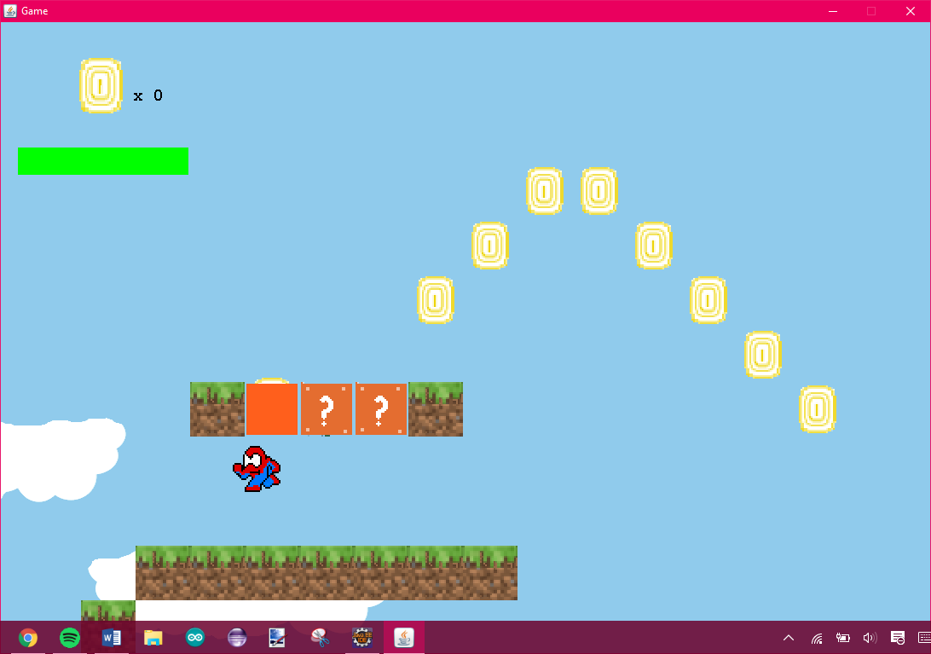 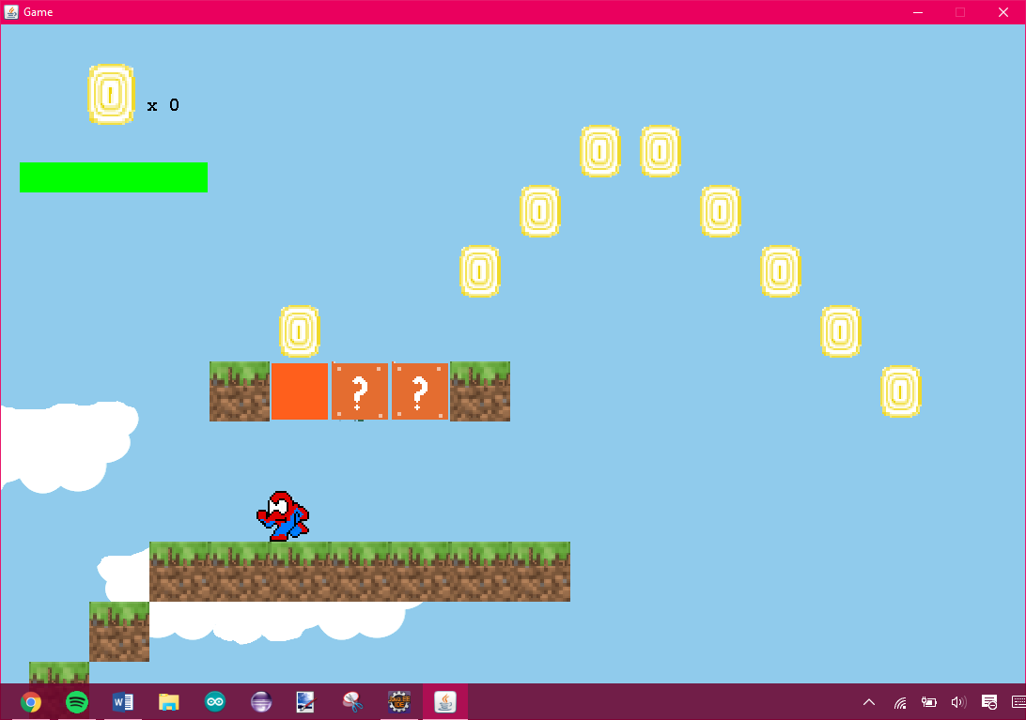

Player Collided with the power up tile Coin appeared

Test Case # 11

Description of Test Case: Mushroom power up

Data Set: Arrow Keys (UP)

Pre-Condition: Player alive

Expected Result: Player should collide with the mushroom and the player should become big

Actual Result: Player collided with the mushroom and the player became big

Screenshots:

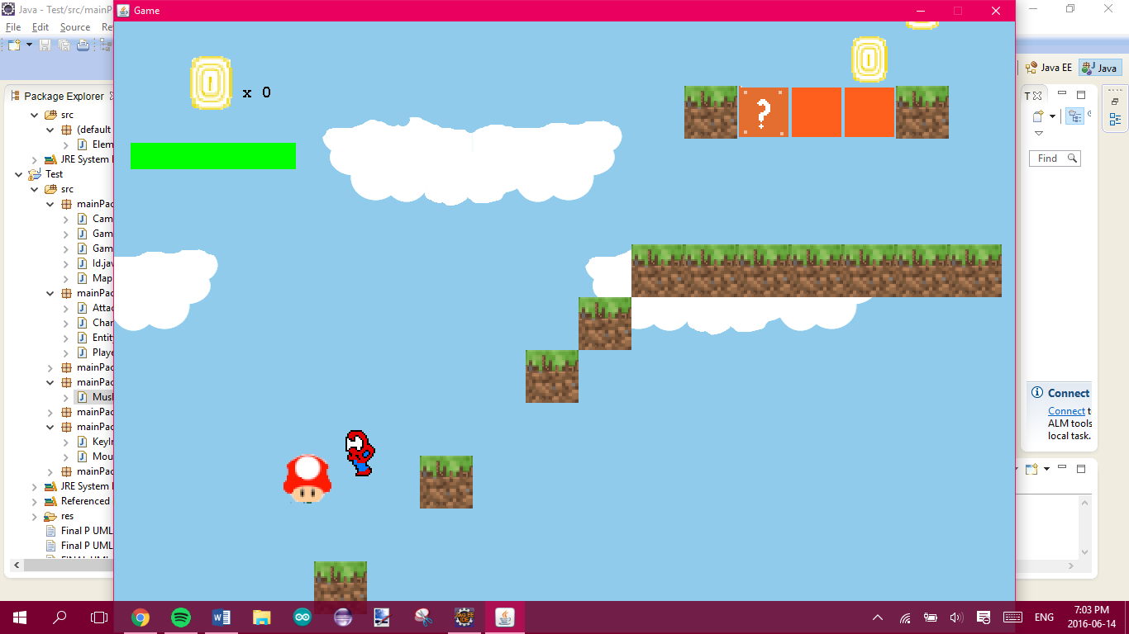 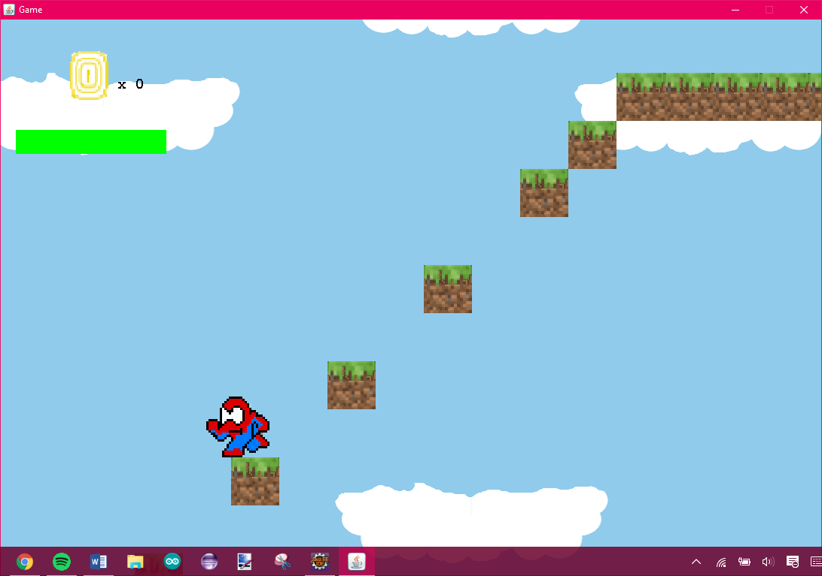

Player collides with mushroom Player is BIG

Test Case # 12

Description of Test Case: Pipe

Data Set: Arrow Keys (DOWN)

Pre-Condition: Player alive

Expected Result:

* BIG player shouldn’t go down the pipe
* SMALL player should go down the pipe

Actual Result:

* BIG player didn’t go down the pipe
* SMALL player went down the pipe

Screenshots:

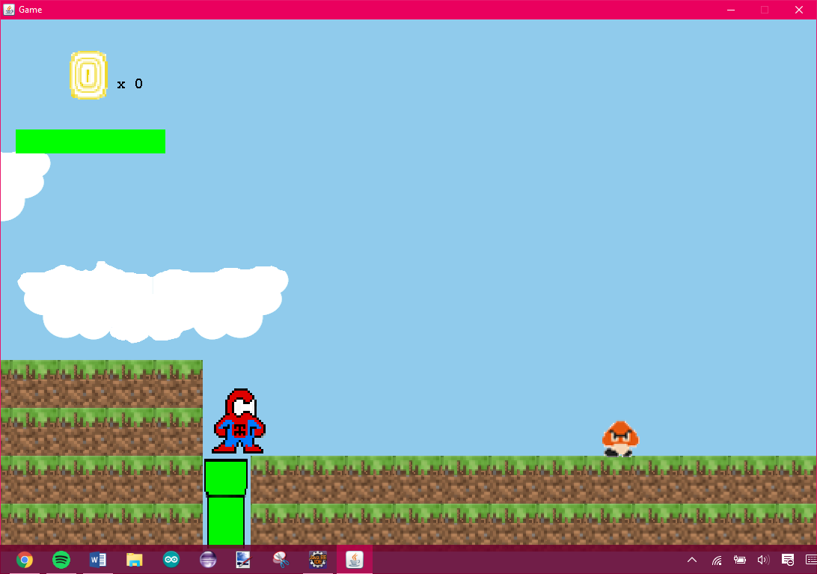 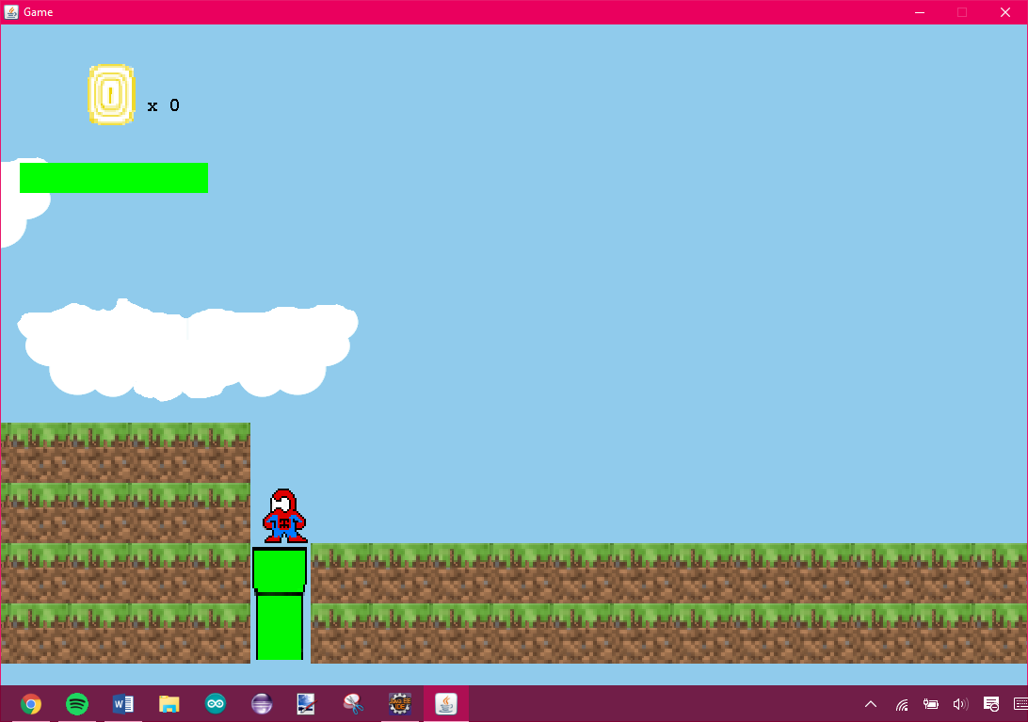

Big player can’t go down Small Player

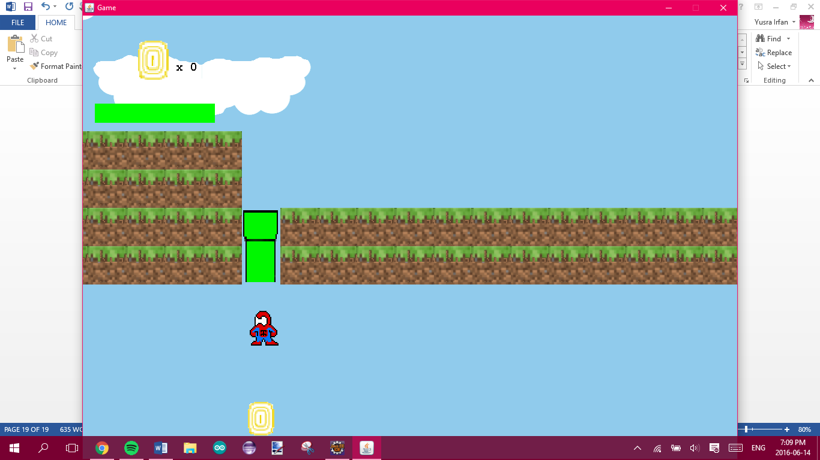

Small Player goes down the pipe

Test Case # 13

Description of Test Case: Player dies

Data Set: Arrow Keys

Pre-Condition: Player alive

Expected Result:

* If player health reaches zero, player dies
* If player falls out of map, player dies

Actual Result:

* When player health reached zero, player died
* When player fell out of map, player died

Screenshots:

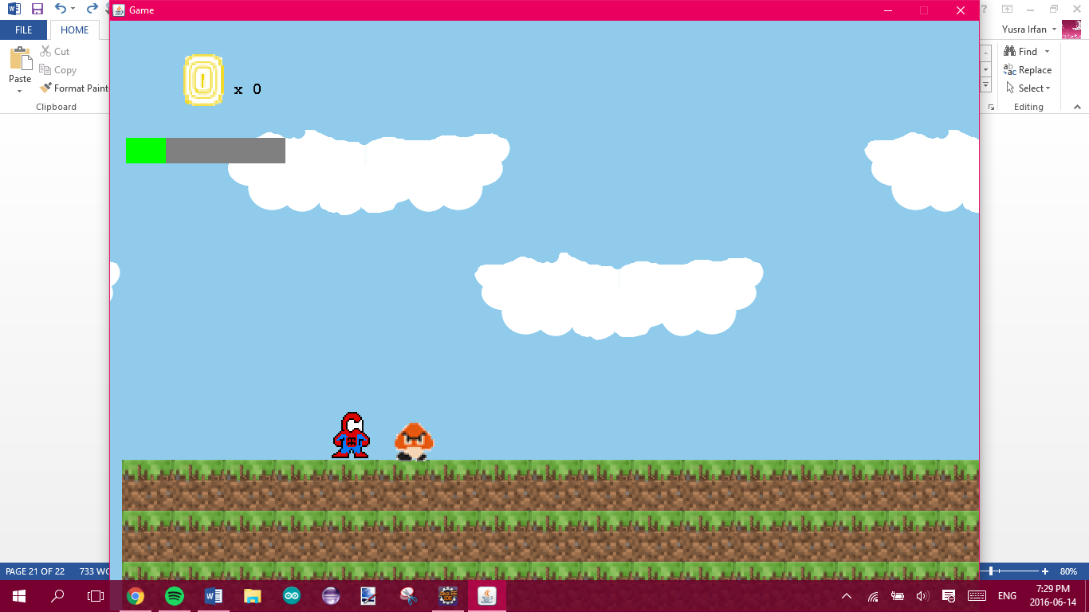 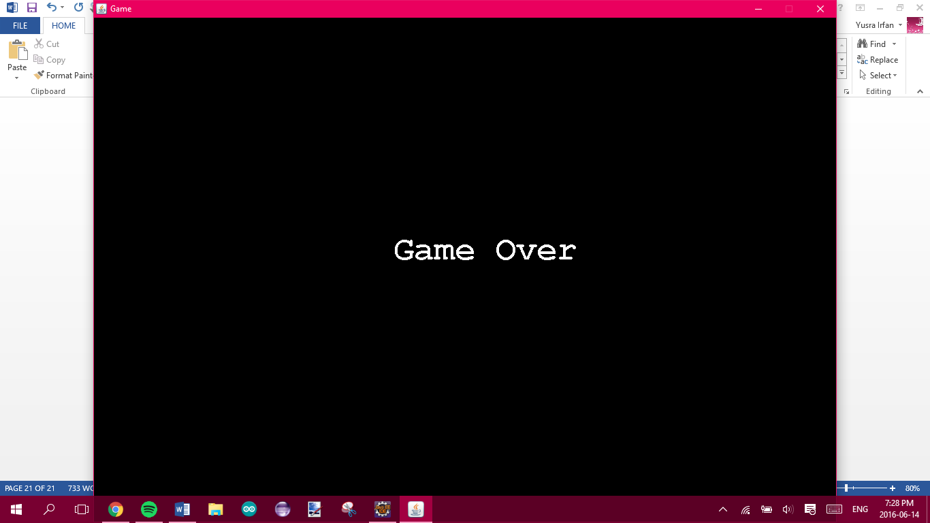

Player Collides with enemy Game Over

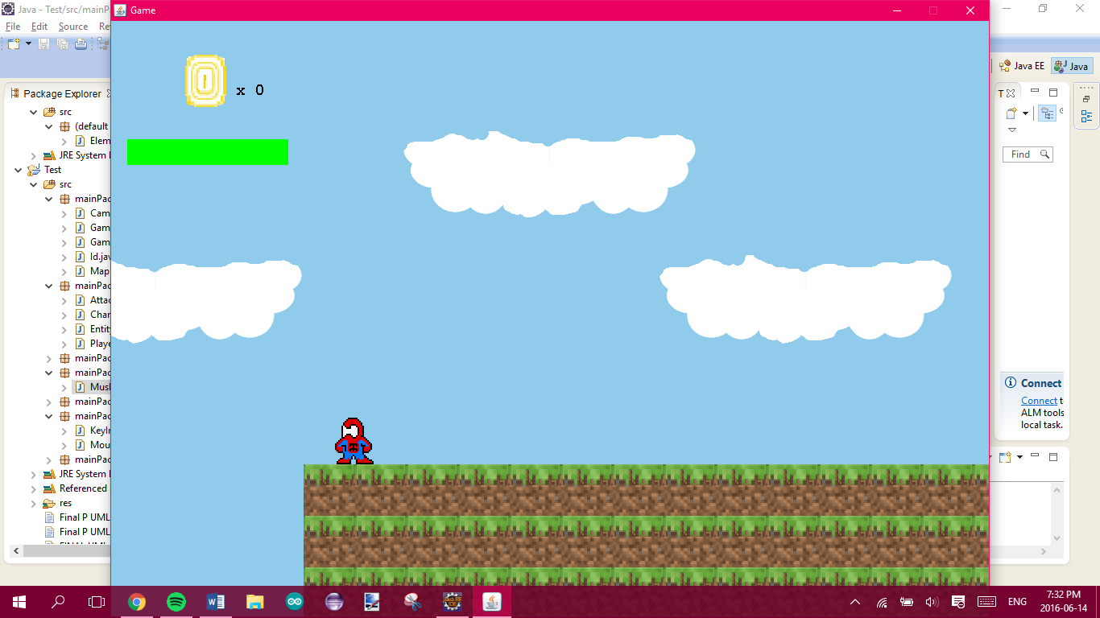 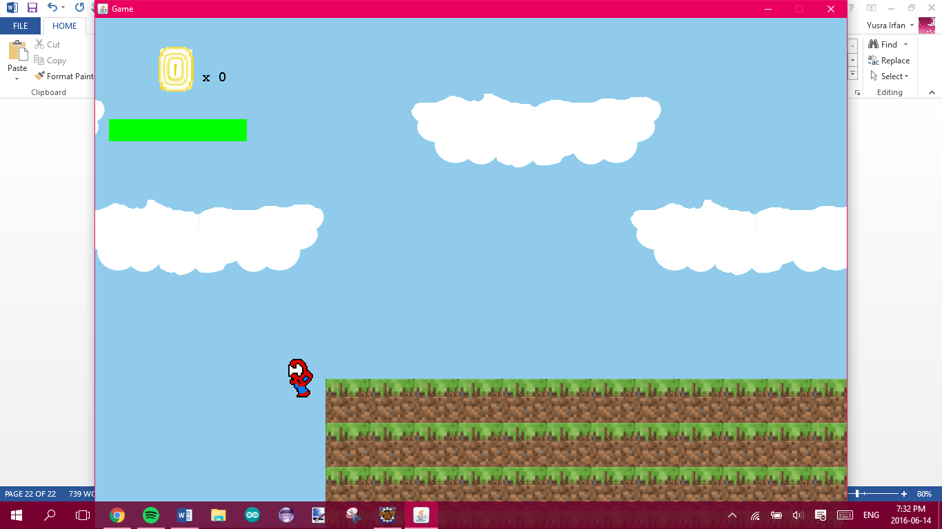

Falls out of the map



Game Over

Test Case # 14

Description of Test Case: Fake Pipe

Data Set: Arrow Keys (DOWN)

Pre-Condition: Player alive

Expected Result: Player shouldn’t go down the pipe

Actual Result: Player didn’t go down the pipe

Screenshots:

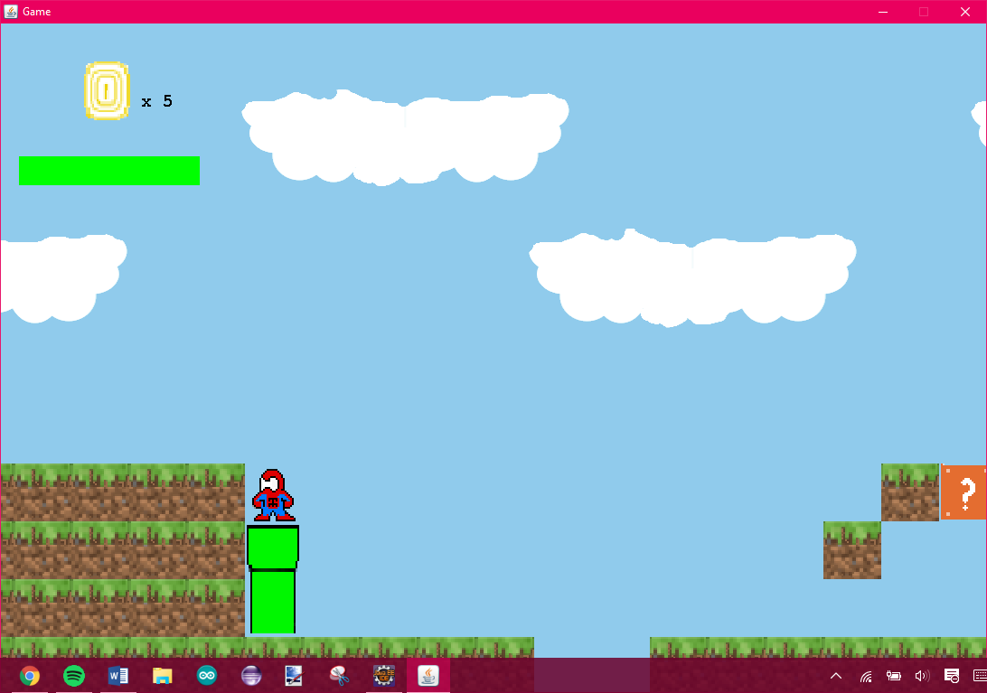

Player on the fake pipe

Test Case # 15

Description of Test Case: Following Boss Enemy

Data Set: Arrow Keys

Pre-Condition: Player alive and level 4

Expected Result: Enemy should follow Player

Actual Result: Enemy follows player

Screenshots:

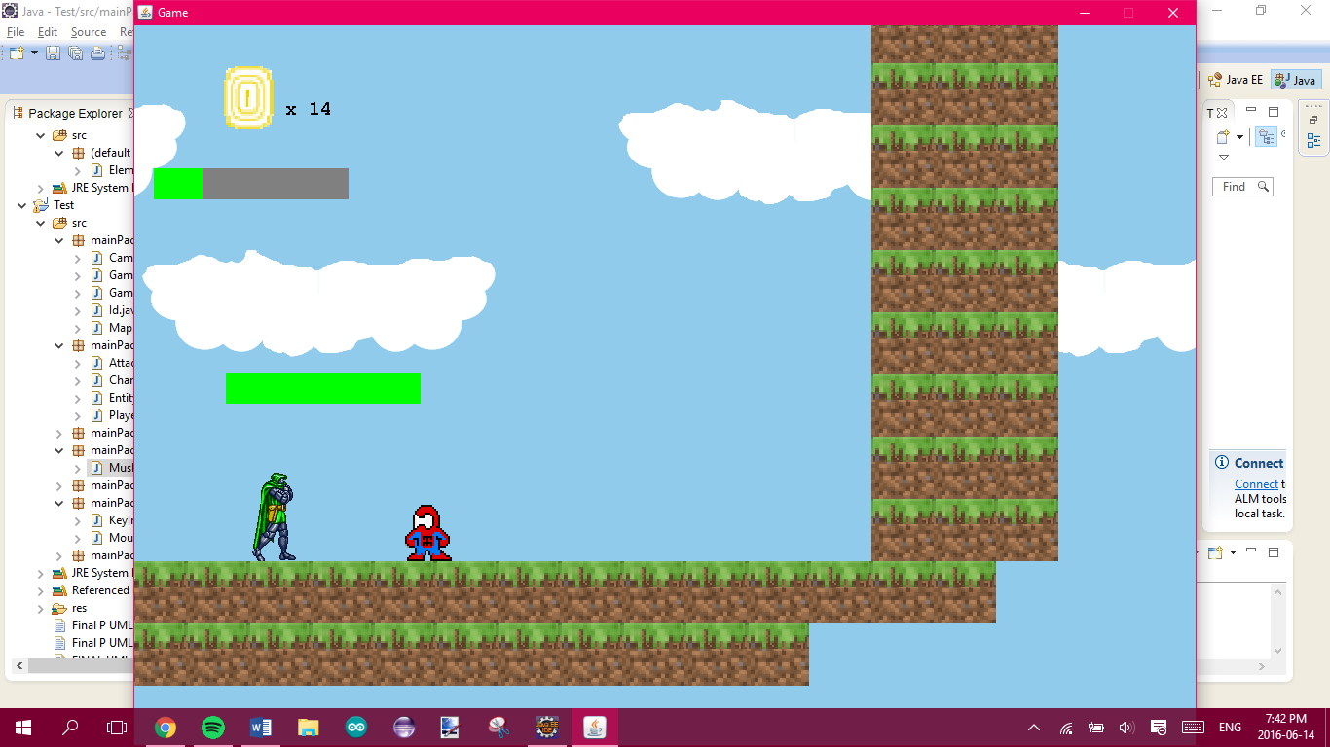 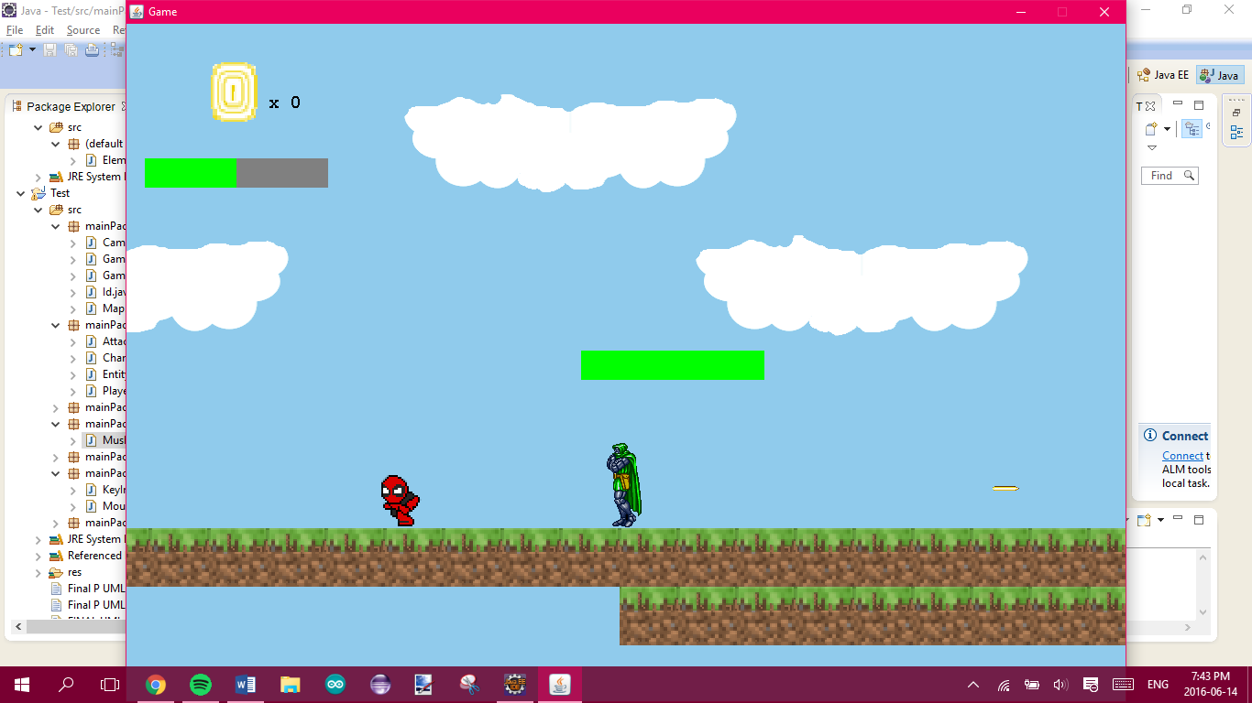

Enemy following on the right Enemy following on the left

Test Case # 16

Description of Test Case: Boss Enemy Shoots at the Player

Data Set: Arrow Keys

Pre-Condition: Player alive and level 4

Expected Result: Enemy should shoot at Player

Actual Result: Enemy should shoot at player

Screenshots:

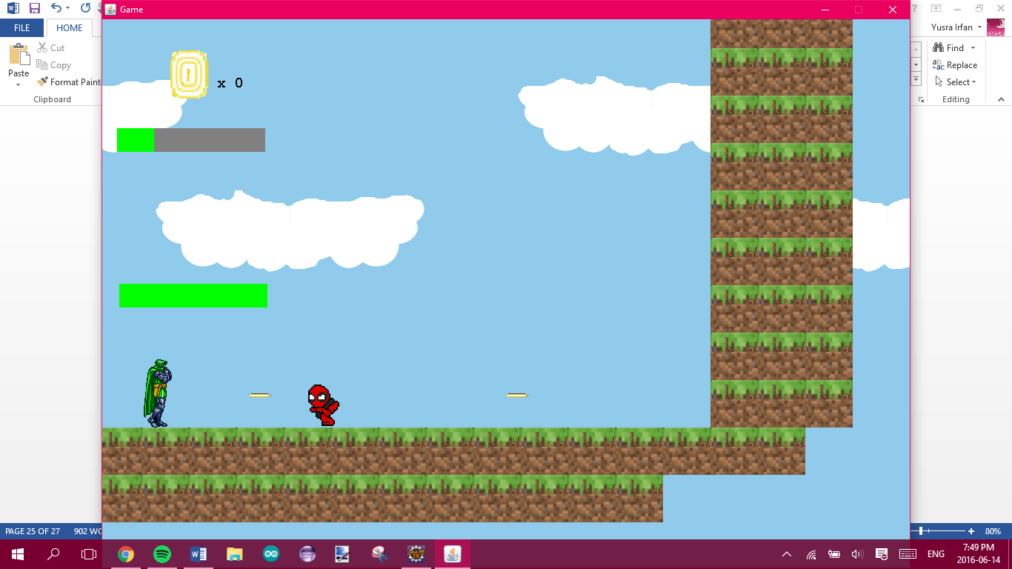 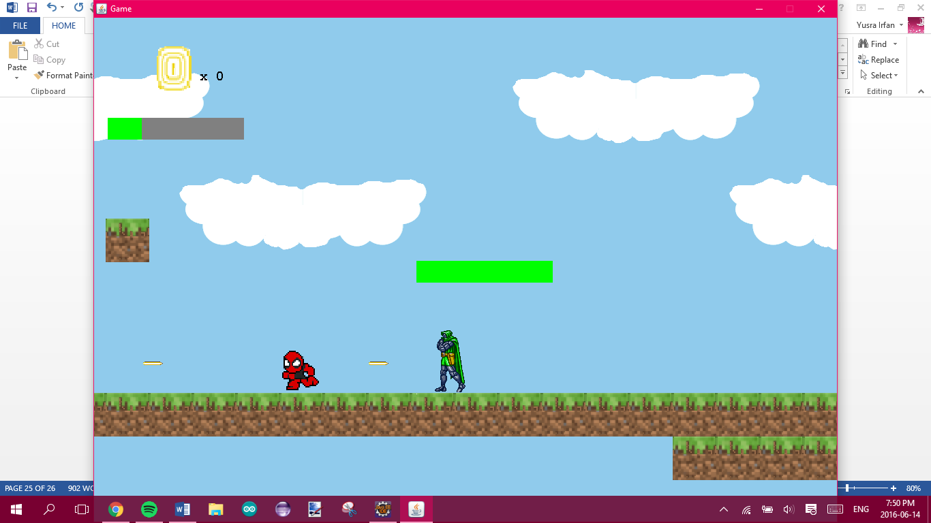

Enemy Attacks on the right Enemy Attacks on the left

Test Case # 16

Description of Test Case: Boss Enemy’s Health decreases

Data Set: Spacebar

Pre-Condition: Player alive and level 4

Expected Result: Enemy’s health decreases

Actual Result: Enemy’s health decreased

Screenshots:

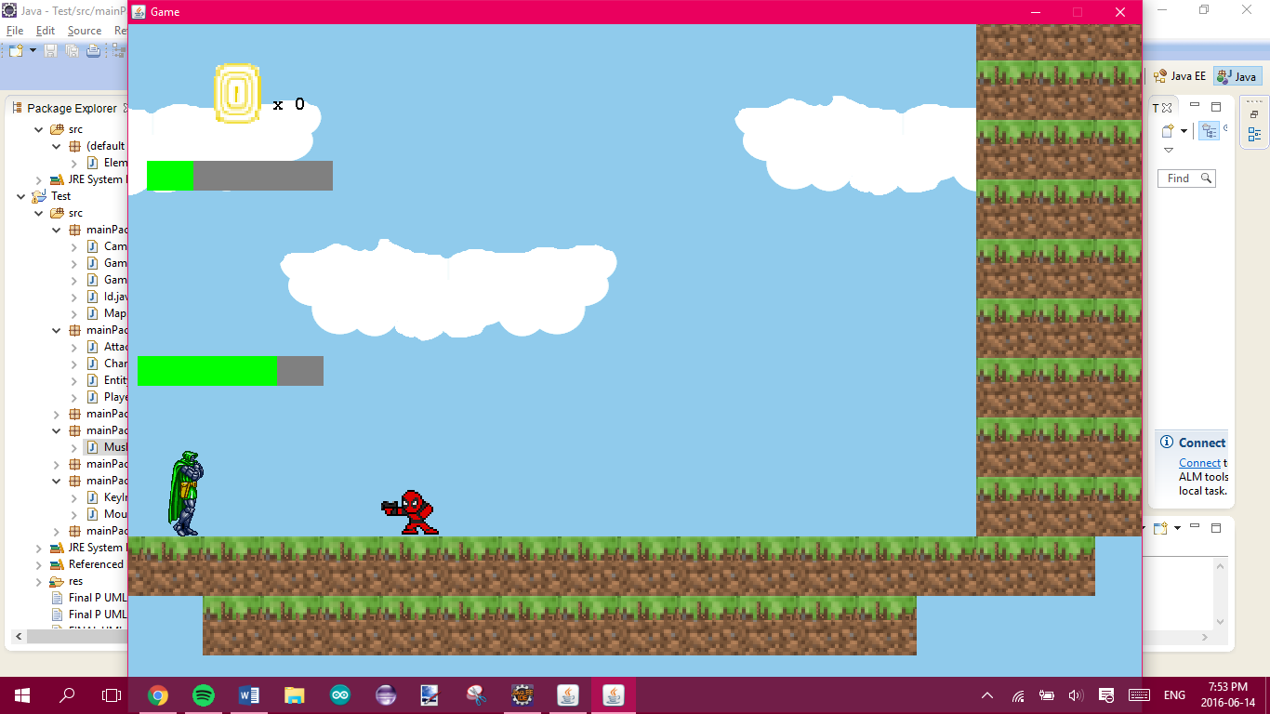

Player attacks the boss